Curriculum Vitae 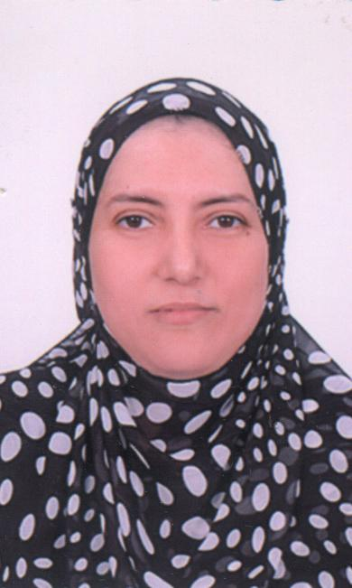

Name :Ebihal Anwar Abedel- Aziz
Address : Ahmed Hassan El-Bakoury Street, Abrag Al-Safoaa, Home No. 4, House No.24, Assiut, Egypt.

Telephone : 002 0889200198 Home.

002 0104605746 Mobile.
E-Mail : ebthal2@yahoo.com
Nationality : Egyptian.
Marital Status : Married with two children.
Birth Date : 24 April 1968.
Place of Birth :Sohag , Egypt.
Sex : female
Haspand's Name, Nationality and Work:
Ashraf Hamouda Abd El-Hakim, Egyptian.
Professor of Dept Anatomy & Emberyology., Faculty of Medicine, Assiut Univ., Assiut, Egypt.
Children (Name, Sex, Date and Place of Birth):
1-Mohamed, male, 2/8/1995, Assiut, Egypt.
2-Ahmed, male, 7/3/1999, Assiut, Egypt.

Qualifications :
• Bachelor of Medicine and Surgery (M.B.B. ch). Sept. 1991 – Faculty of Medicine –Assiut University.
Singed up :Very Good
- October. 1994, First part of M. Sc of Medicine - Faculty of Medicine - Assiut University- Egypt.
Singed up : Good Degree.

• October. 1995, – First part of M. Sc of Medical Physiology –
Branch biochemistry - Faculty of Medicine – Assiut University – Egypt.
Singed up : Excellent Degree.

October . 1998, I have been completed my research Normal predictive values of plumonary function tests in Assiut Governorate as a part of M.Sc. Physiology.

- May. 1999, Master degree of Physiology – faculty of medicine
Assiut University – Egypt.
- Oct.2003, I have been completed my research Effect of training period on some pulmonary functions and physical work capacity of students of faculty of physical education of Assiut University as a part of MD. Physiology.
- May .2004, MD. Degree of physiology – faculty of medicine
Assiut University – Egypt.
- September 2009 Associate professor of physiology Assiut Univ.

Experiences :
- From Mars, 1992 to Feb. 1993 Assistant Resident of Assiut Univ. Hospital.
- From Mars, 1993 to October. 1994 Resident at department of Medicine in Assiut Univ Hospital.
- From April, 1994 to. June 1996 as demonstrator of physiology–faculty
of medicine –Sohag University – Egypt.
• From Jul, 1996 to May. 1999 as demonstrator of physiology–faculty
of medicine – Assiut University – Egypt.
• From Jun , 1999 to May. 2004 as Assistant Lecturer of Physiology – faculty
of medicine – Assiut University – Egypt.
- From Jun 2004. till now Lecturer of Physiology – faculty of medicine – Assiut University – Egypt.

- Teaching Both Practical and Theoretical courses in Human Physiology to undergraduate students of Faculty of medicine– Assiut University – Egypt.
- Teaching Both Practical and Theoretical courses in Human Physiology to postgraduate students of different Departments in Faculty of medicine – Assiut University – Egypt.
- Teaching Both Practical and Theoretical courses in Human Physiology to students of in faculty of pharmacy and Nursing Faculty.
- Supervising and performing researching with other researchers in different Departments.
Researches:
1- Relationship Between Serum Parathyroid Hormone
and Trace Elements (Serum Zinc and Magnesium)
in Hemodialyzed Chronic Renal Failure Children
Azza A. El Tayeb* & Nashwa A. Abd El-Mottaleb & Ebtihal A. Abdel Aziz
Dept. of Pediatric*, Physiology, Faculty of Medicine Assiut University

Biol Trace Elem Res Vol.(128) , No.(2) May (2009)

2- HISTOLOGICAL AND PHYSIOLOGICAL STUDIES TO EVALUATE THE PROTECTIVE EFFECT OF HONEY ON PARACETAMOL INDUCED TESTICULAR LESI0NS IN ADULT ALBINO MALE RATS
Heba Mohammed Saad Eldeen*,Ebtihal Anwar AbdeL-Aziz** and Hoda A.M.Abdel-Aziz***. Assiut Med. J.Vol. (30), No. (2), May,2006

3- PROTECTIVE EFFECTS OF OLEANOLIC ACID AND
VITAMINE E ON THYROID DYSFUNCTION AND LIPID
PEROXIDATTON IN CADMIUM- INDUCED TOXICITY
IN RATS
Faten M. Omran¹, Nagwa S. Ahmed², Ebtihal A. Abdel- Aziz³ and Soheir A. Mohamed ⁴ J. Egypt. Soc. Toxicol. Vol.36:67-75 Jan. 2007

4- NICOTINE IMPACT ON TESTIS, EPIDIDYMIS AND SEMEN PATTERN IN ADULT MALE RATS

Ashraf H. Abd el-hakeem*, Ebtihal A. Abd El Aziz**, Salwa I. Wasfi** and Nashwa A. Abd el Motaleb**
Anatomy* and physiology** departments, faculty of medicine, assiut universty
Assiut Med .J. Vol. (33), No.(1),January, 2009

5- CHANGES IN LUNG FUNCTIONS AMONG PATIENTS
WITH DIABETES MELLITUS
Safaa Mokhtar Wafy, Ebtihal A. Abdel- Aziz *,
Asmaa Farghaly Hassan* and Hussein A. El Amin**
Departments of Chest Diseases, Physiology* and Internal Medicine**
Faculty of Medicine, Assiut University
The Medical Journal of Cairo University, Vol.(76), No.(4), (Suppl. II) December 2008

6- FASTING DURING RAMADAN: DOES IT ALTER PULMONARY FUNCTIONS IN HEALTHY MALES?
Ebtihal A. Abdel-Aziz* and Abdel-Rady S. Ibraheem**
*Department of Physiology, Faculty of Medicine, Assiut University.
** Department of anesthesia, Faculty of Medicine, Assiut University.

AAMJ, Vol. (6), N.(3), September, 2008

7- MEABOLIC CHARACTERIZATION, PLASMA LEPTIN AND INSULIN RESISANCE OF STRESSED RATS.

Khaled A. Abdel-Sater, Ali A. A. Khalil and Ebtihal A. Abdel-Aziz*
Physiology Department, Al-Azhar Faculty of Medicine (Assiut) and Assiut Faculty of Medicine*

AAMJ, Vol. (4), N.(3), September, 2006

Other Courses and Training :
- Courses for developing teaching activity of university lectures in Assiut University in February 2000.

Different Courses in computer including :

- Windows XP.
- Word Processing Program, SPSS programs
- Microsoft Power Point &
- Internet Explore.

Language :
Arabic : Native Language.

English : First Foreign Language, Very Good (Writing,
Reading and Speaking).

French : Second Foreign Language, little writing and reading.

Signature

